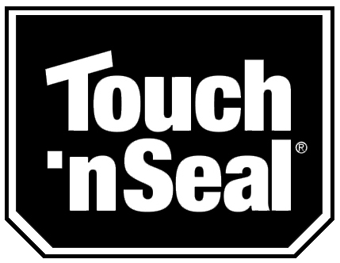

NEWS RELEASE
Editor’s note: Hi-res photos available upon request
Media Contact:
Carolyn Schinsky / Ryan PR / 314-822-9784/ carolyn@ryan-pr.com

Ozark Utility Credits Touch ‘n Seal with Help in Getting Reefer Trailers Back on the Road in Record Time

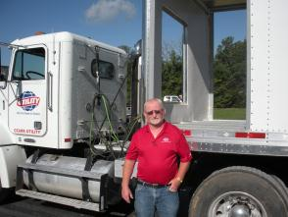
Mike Loveland, Service Manager at Ozark Utility, is committed to getting damaged refrigerated trailers back on the road as quickly as possible. Photo courtesy of Ozark Utility

ST. LOUIS—July 16, 2012—Established in 1981, Ozark Utility is a franchised dealer of Utility, the makers of more than 50 percent of the refrigerated trailers sold in the United States. Based in Springfield, MO, the company is a full service Truck Trailer Dealership offering sales, repair services and parts. Beyond providing superior customer service and quality products and parts to their customers, Ozark Utility is committed to getting damaged refrigerated trailers back on the road in record time.

Mike Loveland, Service Manager at Ozark Utility and 25 year-company veteran, says it’s not unusual to have seven or eight wrecked trailers serviced every month at their repair facility. His team of expert technicians depends on Touch ‘n Seal’s quality Customer Service, 17-gallon Refillable Foam System and Liner Bond Trailer Adhesive to return damaged refrigerated trailer trucks back to their original condition as quickly as possible.

Going the extra mile with customer service wins over business.

For years, Ozark Utility had been using a competitor of Touch ‘n Seal’s foam systems and were satisfied with the product’s performance. The status quo was altered when Chuck Bahuriak, Director of Sales-IBM Division Specialty Markets at Touch ‘n Seal, entered the picture.

When Bahuriak first met with Loveland to introduce him to Touch ‘n Seal’s line of polyurethane foam systems for the transportation industry, Loveland explained they were content with the performance of the foam system they were currently using. After listening to what he had to say, Bahuriak suggested Loveland contact the service team at Craftsman Industries, a Utility franchise in St. Louis using Touch ‘n Seal’s foam systems to repair their refrigerated trailers.

Loveland took Bahuriak’s suggestion and contacted Craftsman. “I liked Chuck’s non-pushy approach. He genuinely wanted me to get some honest feedback from someone who was using Touch ‘n Seal’s products so I could form my own opinion,” says Loveland.

For almost a year Loveland gathered feedback on Touch ‘n Seal’s customer service and product performance. Impressed with what he heard, he decided to give Touch ‘n Seal a try, citing “outstanding customer service” as the number one reason for finally placing an order for the company’s 17-gallon Refillable Foam System and Liner Bond Trailer Adhesive.

“Deciding to place that order was one of the best decisions I’ve ever made,” states Loveland. “The level of service provided by Chuck and his team help us quickly get the trailers at our facility repaired and back on the road. For example, they typically will have a rep on site within 24 hours if we experience any type of issue. With our previous supplier, we’d wait far longer just to hear back from someone, much less have someone appear on site.”

Touch ‘n Seal products speed up recovery of refrigerated trailer trucks.
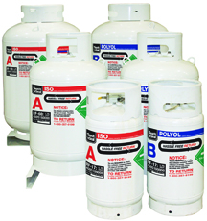
One of Ozark’s Utility’s most common reefer trailer repairs are to damaged sidewalls of 53’ x 102” Utility trailers. The company uses Touch ‘n Seal’s 17-gallon Refillable Foam System to apply foam to repaired sidewall panels as well as floors and ceilings, when needed. Designed for efficient dispensing of premium Class 1 fire-retardant spray foam, the Refillable system is a cost-effective alternative for high-volume users like Ozark Utility who don’t wish to invest in a full-scale foam rig.
Touch 'n Seal Refillable Foam Systems

“The Refillables provide consistent quality, fast results and they’re easy-to-use” says Loveland. “They have a better foam yield than the system we were previously using. On average, one 17-gallon canister set supplies us with enough foam to refurbish the entire side wall. Plus, returns are a breeze with prepaid freight and easy pick-up when we’ve emptied the units.”

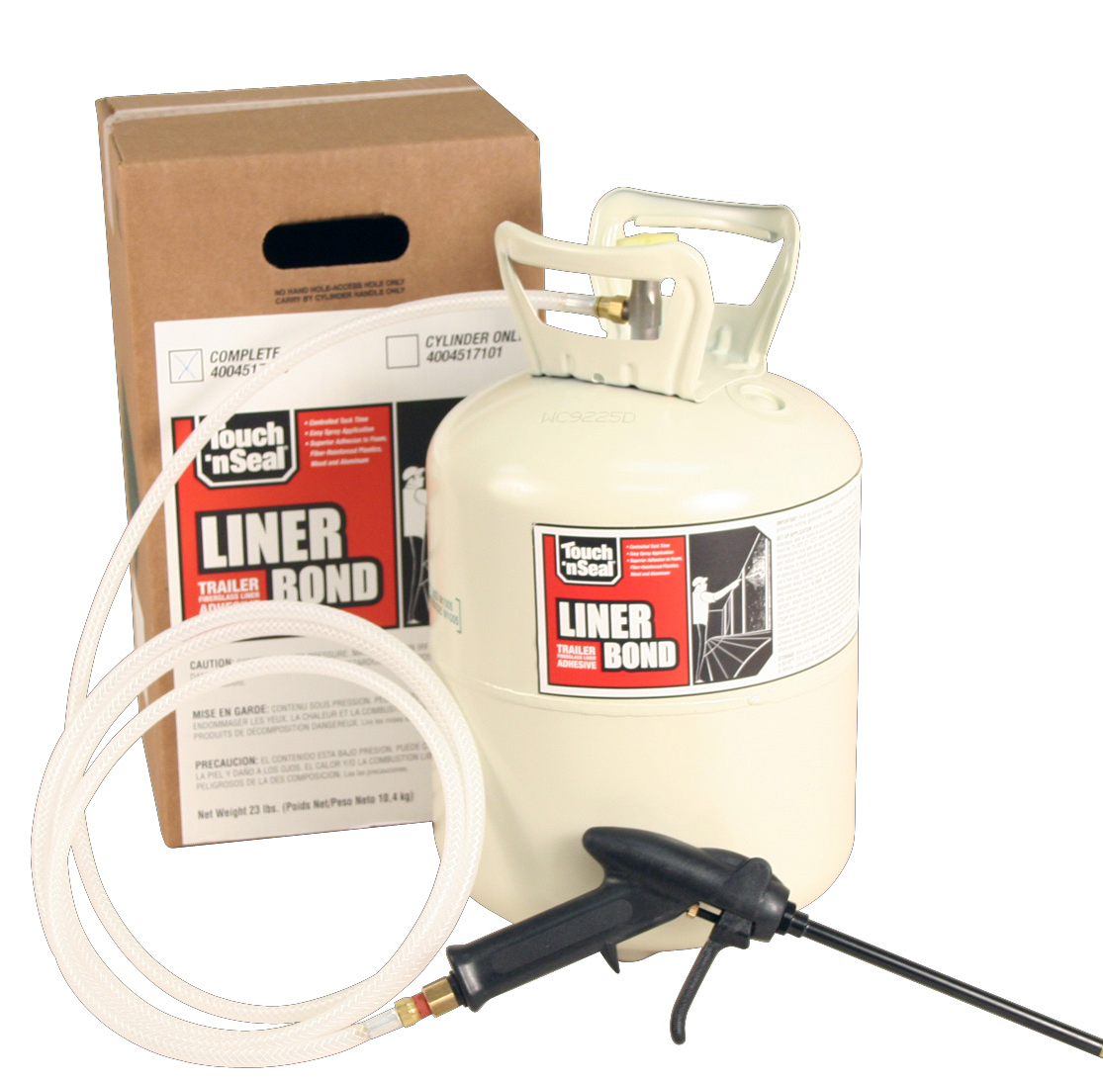
Ozark Utility also uses Touch ‘n Seal’s portable, ready-to-use Liner Bond Trailer Adhesive to bond fiberglass liners to the prepared spray foam insulation. Five times stronger than other foam adhesives, Liner Bond offers total liner adhesion with a 30 minute open time, allowing plenty of time for proper liner placement.

“We used to use an adhesive with a 72 hour cure time,” says Loveland. “Liner Bond has a 24 hour cure time, which significantly reduces our down time and gets the trailers back on the road sooner.”
Touch 'n Seal Liner Bond Adhesive

According to Loveland, his service team can typically restore damaged trailers back to original structural strength and insulation efficiency within a 10-day period. “Thanks to Touch ‘n Seal’s outstanding Customer Service and dependable products, we are setting the standard for putting damaged reefer trailers back on the road faster than ever before.”

Find out more about Touch ‘n Seal’s foam systems for the transportation industry at http://www.touch-n-seal.com or contact Touch ‘n Seal customer service at 800-325-6180.

Ozark Utility is located at 3650 E. Evergreen, Springfield, MO 65803 and on the web at www.ozarkutility.com.

# # #

About Touch ‘n Seal
Convenience Products, the manufacturer of Touch ‘n Seal products, is headquartered in St. Louis, Missouri. Touch ‘n Seal insulating foams and sealants are the benchmark for performance in commercial and industrial building and maintenance, OEM manufacturing and specialty applications. A full line of one and two-component spray foams and adhesives are available, including fire blocking foam (ICC-ES: ESR-1926), Low Pressure Window & Door Foam, Drywall Panel Adhesives, Heating Systems and Accessories, Two-Component, Disposable Units, Mining Specialty Units and One-Component Disposable Cylinders. Spray foam is available from 15-board feet kits to 120-gallon refill systems. One-component straw and gun foam available in 12 to 30.5 oz. aerosol cans. More information is available at www.touch-n-seal.com, www.facebook.com/TouchNSeal and www.twitter.com/TouchNSeal.

