NEWS RELEASE
Contact Information:
Carolyn Schinsky / Ryan PR / 314-822-9784/ carolyn@ryan-pr.com

Touch ‘n Seal Introduces 2.0 PCF Spray Foam
Class 1 Fire Retardant Foam offers increased structural strength & support, superior sound control and thermal insulation

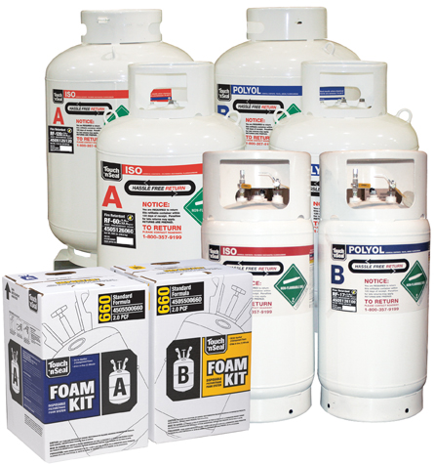
ST. LOUIS—Nov. 11, 2011— Convenience Products, the manufacturer of Touch ‘n Seal Insulating Foams and Sealants, introduces FR Two-Component Class 1 Fire Retardant Foam, a thermal insulating and sound attenuating polyurethane spray foam. The fire retardant, 2.0 PCF foam is suitable for use in commercial, residential and transportation applications — anywhere denser, stronger foam is needed.

The new Class 1 Fire Retardant Spray Foam meets the International Code Council Evaluation Services’ (ICC-ES) listing. It also meets the flammability test requirements of Acceptance Criteria 377 Appendix X which assesses the fire performance of spray-applied polyurethane foam insulation materials for use in attic and crawl spaces without a prescriptive ignition barrier.

“Touch ‘n Seal’s new FR Spray Foam is a great choice for both new construction and renovation projects,” says Michael Sites, Touch ‘n Seal Marketing Manager. “It’s quick and easy to apply and it significantly increases structural strength and stops energy-robbing air infiltration.”

Other Touch ‘n Seal FR Two-Component Class 1 Fire Retardant Spray Foam features include:

- High compressive bond strength
- Fast cure that dries within minutes of application
- Reduces energy loss by as much as 40%
- Closed cell structure
- High R-value
- Permanent insulation maintains air seal — will not shrink or settle like cellulose
- Compatible with all fiber insulation systems including cellulose, fiberglass and rockwool
- Environmentally friendly — no ozone depleting chemicals and reduces use of fossil fuels
- Reduces air exchanges by expanding to fill smallest to largest gaps, cracks and holes

FR Two-Component Class 1 Fire Retardant Spray Foam is available in disposable chemical cylinders (CP660) as well as 17-, 60- and 120-gallon refill systems. These refill systems allow quick and easy foam application for repairs and renovations, new installations and production applications.

For more information, visit http://www.touch-n-seal.com or contact Touch ‘n Seal customer service at 800-325-6180.

# # #

About Touch ‘n Seal
Convenience Products, the manufacturer of Touch ‘n Seal products, is headquartered in St. Louis, Missouri. Touch ‘n Seal Insulating Foams and Sealants are the benchmark for performance in Commercial and Industrial Building and Maintenance, OEM Manufacturing and Specialty applications. A full line of one and two-component spray foams and adhesives are available, including Fire Blocking Foam (ICC-ES: ESR-1926), Marine Foam, Low Pressure Window &Door foam, Roof Tile Adhesive, Drywall Panel Adhesives, Foam Heating Systems and Accessories, two-component disposable kits, Mining Specialty kits and one-component disposable cylinders. Spray foam is available from 15-board feet kits to 120-gallon refill systems. One-component straw and gun foam is available in 12 to 30.5 oz. aerosol cans. For more information, visit http://www.touch-n-seal.com.

